Project Design Phase-II
Technology Stack (Architecture & Stack)

Date | 31 January 3035
Team ID | LTVIP2025TMID45799
Project Name | TrafficTelligence: Advanced Traffic Volume Estimation with Machine
Maximum Marks | 4 Marks

Technical Architecture:
The Deliverable shall include the architectural diagram as below and the information as per the table1 & table 2
Example: Order processing during pandemics for offline mode
Reference: https://developer.ibm.com/patterns/ai-powered-backend-system-for-order-processing-during-pandemics/
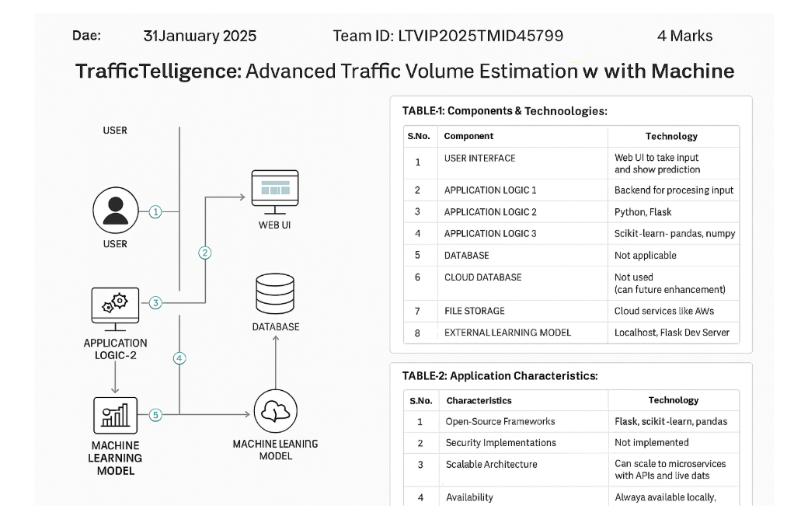

Table-1 : Components & Technologies:
S.No | Component | Description | Technology
 | User Interface | Web UI to take input and show prediction | HTML, CSS, JavaScript
 | Application Logic-1 | Backend for processing input | Python, Flask
 | Application Logic-2 | ML-based prediction logic | scikit-learn, pandas, numpy
 | Application Logic-3 | Not applicable | —
 | Database | Local CSV or SQLite for storing logs | CSV, SQLite
 | Cloud Database | Not used (can be future enhancement) | —
 | File Storage | For saving prediction logs | Local filesystem
 | External API-1 | Weather Data API (optional future enhancement) | OpenWeatherMap API (optional)
 | External API-2 | Not applicable | —
 | Machine Learning Model | Predict traffic volume using trained model | RandomForestRegressor (scikit-learn)
 | Infrastructure (Server / Cloud) | Deployment and hosting | Localhost, Flask Dev Server (can move to AWS/GCP)

Table-2: Application Characteristics:
S.No | Characteristics | Description | Technology
 | Open-Source Frameworks | List the open-source frameworks used | Flask, scikit-learn, pandas
 | Security Implementations | Basic data validation (no login implemented). | Not implemented
 | Scalable Architecture | Can scale to microservices with APIs and live database later | Flask (monolithic now, can modularize)
 | Availability | Always available locally; can deploy on cloud for 24x7 access | Cloud services like AWS, GCP (future)
 | Performance | Fast prediction with lightweight ML model | Efficient backend, low latency Flask

References:
https://c4model.com/
https://developer.ibm.com/patterns/online-order-processing-system-during-pandemic/
https://www.ibm.com/cloud/architecture
https://aws.amazon.com/architecture
https://medium.com/the-internal-startup/how-to-draw-useful-technical-architecture-diagrams-2d20c9fda90d

